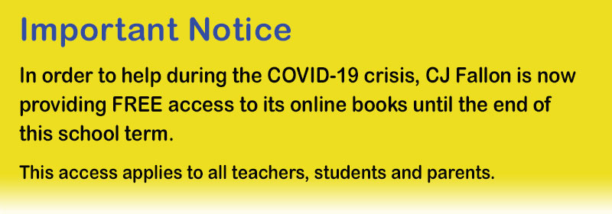

As of today, in response to the COVID-19 crisis, teachers, parents and pupils can access the online versions of all CJ Fallon books for free. Simply click here and filter to your required title.
If you would prefer to access these directly, visit http://my.cjfallon.ie, click 'Student Resources', then filter to the title you require, making sure 'Online Book' is selected under 'Resources'.
Kind regards, and stay safe.
CJ Fallon

